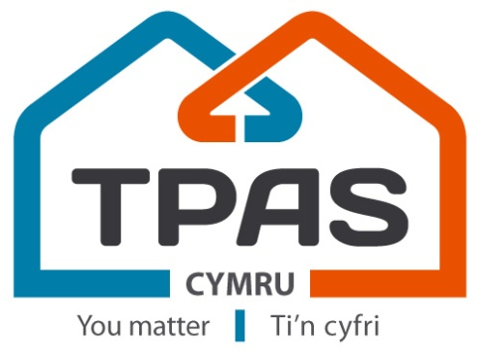
TENANT PULSE

About You –
- What title do you prefer?
Mr |  | Mrs |  | Miss |  | Dr |  | Other

- First Name

- Last Name

- What email would you like to be contacted on?

- House name/number

- County

- Postcode

- Contact Number

- Age Range
16 – 24
25 – 34
35 – 44
45 – 54
55 – 64
65 – 74
75+
Prefer not to say

- What is your gender?
Male
Female
Prefer not to say

- Employment Status
Retired
Working Full-Time
Working Part-Time
Full Time Student
Unemployed
Other(Please specify)

- Do you consider yourself to have a disability?
Yes
No
Do not wish to disclose

- Are you a Welsh speaker?
Yes
No

- How would you describe your ethnicity?
English
Welsh
Scottish
Northern Irish
British
Caribbean
African
Indian
Pakistani
Bangladeshi
Chinese
European
American

- What is your current living position?
Tenant of Housing Association
Council/Local Authority Tenant
Private Rental Sector
Other

- If you’re a tenant of a housing association, please tick the name of your social landlord.
Seren Living |  | Abbeyfield Total
Aelwyd Housing Association |  | Almshouse Total
Baneswell Housing Association |  | Bangor Diocesan Housing Association
Bro Myrddin Housing Association |  | Bron Afon Community Housing Association
Cadwyn Housing Association |  | Cardiff Community Housing Association
Cardiff YMCA Housing Association |  | Care and Repair in Powys
Cartrefi Cymunedol Gwynedd |  | Castle Housing Association (Wales)
Charter Housing Association |  | Clwyd Alyn Housing Association
Coastal Housing Group |  | Cymdeithas Tai Eryri
Hafan Cymru |  | Cynon Taf Housing Association
Cyon Taf Community Housing Group |  | Dewi Sant Housing Association
Eastern Valley Housing Association |  | Fairlake Living
Fairlake Properties |  | First Choice Housing Association
Gwalia (Rest Bay Co-Ownership) Housing Association |  | Gwalia Housing Group
Gwerin (Cymru) Housing Association |  | Gwynfyd Housing Co-Operative
Hafod Care Housing Association |  | Hafod Housing Association
Monmouthshire Housing |  | Newport City Homes
Derwen |  | Newtown Housing Association
Newydd Housing Association |  | NPT Homes
Pembrokeshire Housing 2000 |  | Pembrokeshire Housing Association
Polish Housing Society |  | Pontyridd and District Housing Association
RCT Homes |  | Rhondda Housing Association
Saint Davids Diocesan Housing Association |  | Soroptimist Housing Association (Camarthen)
Soroptimist Housing Association (Tenby) |  | Swansea Housing Association
Taff Housing Association |  | Tai Calon Community Housing
Tai Ceredigion |  | Ty Glas Housing Society
United Welsh Housing Association |  | Valleys to Coast Housing
Wales and West Housing |  | Young Womens’ Housing Association

- If you’re a tenant of a council/local authority, please tick the name of your local authority.
Isle of Anglesey |  | Vale of Glamorgan
Cardiff |  | Denbighshire
Flintshire |  | Wrexham
Powys |  | Caerphilly
Pembrokeshire |  | Carmarthenshire
Swansea

