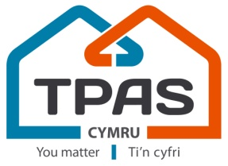
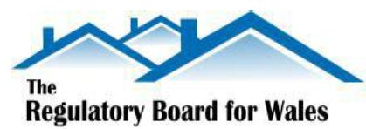
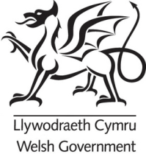

Hearing the Tenants Voice in the Regulation of Housing Association in Wales

Who Regulates Housing Associations in Wales?
Housing Associations in Wales, also known as ‘Registered Social Landlords’ (RSLs), are regulated by The Welsh Government’s Housing Regulation Team. The aim of regulation is to protect Tenants and Investment in Welsh Housing Associations.

The work of the Regulation Team is overseen by the Regulatory Board for Wales (RBW)

What is the Regulatory Board for Wales (RBW)?
The Regulatory Board for Wales (RBW) is independent and made up of key housing figures from across the UK.

The purpose of the board is to examine the regulatory performance and activity of the Welsh Government and the housing sector.

Understanding and hearing the views of tenants of housing associations is important to the Board and the Regulation Team so that tenants’ concerns and interests are reflected in their work. They want to be able to find out about tenants’ priorities and concerns generally and views on important priority areas such as value for money. They also want feedback from tenants across Wales regarding their broad satisfaction with their housing association’s services & tenant engagement.

The Regulatory Board want to build a picture of tenants’ general views over time and hear if regulation is working from a tenants’ perspective. The Board it is not able to deal with specific complaints from tenants, these should be dealt with via the landlord’s complaints policy or through the Public Service Ombudsman for Wales - http://www.ombudsman-wales.org.uk/
How will the voice of tenants be heard by the RBW?
To gather tenants views the Board and Regulation Team are working with TPAS Cymru who will use a range of ways for tenants to be engaged. These will include gathering tenant views at regional tenant networks and events; focus groups and forums to discuss specific issues.

TPAS Cymru have also set up the new ‘Tenant Pulse’ – a survey community where tenants can give their views by email or post. ‘Tenant Pulse’ is free to join and for each survey completed members are entered in a prize draw.

To join ‘Tenant Pulse’ follow the link on the website www.tpas.cymru/about/tenant-pulse or contact TPAS Cymru for a paper application or for the information in different format/languages (02920 237303)

How the Tenant voice in regulation is working is being monitored through a ‘Making it Work’ Steering Group, made up of members of RBW, Regulation Team, Regulatory Advisory Group and TPAS Cymru.

Further information
Further information about Housing Association Regulation in Wales is available following the links below:

http://www.tpas.cymru/blog/the-regulatory-board-for-wales-a-tenant-overview

http://gov.wales/topics/housing-and-regeneration/services-and-support/regulation/?lang=en

http://gov.wales/topics/housing-and-regeneration/services-and-support/regulation/regulatory-assessments/?lang=en

Updated – Sept 2017. DL

