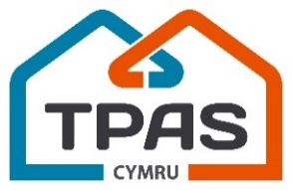
Annual General Meeting
11am: Tuesday 14th November
Online Zoom Webinar

AGENDA

1. Opening welcome and address
Bill Hunt, (Chair, TPAS Cymru)

2. The 2020 – 2021 Annual Report and Finance Report
David Wilton (Chief Executive, TPAS Cymru)

4. Board Update
Bill Hunt (Chair, TPAS Cymru)

5. Delivery Update and your views on next year’s priorities
David Lloyd (Programme Director, TPAS Cymru)

6. Questions and Answers
Vicki Miller, Vice Chair, TPAS Cymru)

7. Formal Close and Thanks

