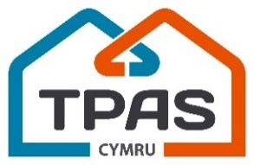
Annual General Meeting
5pm, Tuesday 14th November
Metropole Hotel, Llandrindod Wells

AGENDA

1. Opening welcome and address
Emma Parcell , (Chair, TPAS Cymru)

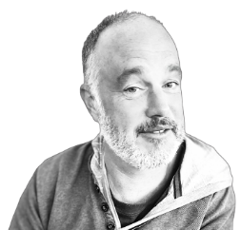 | 2. The 2022 – 2023 Annual Report  David Wilton (Chief Executive, TPAS Cymru)  3. Finance Report  Martin Little (Finance & Operations Manager, TPAS Cymru)
4. Delivery Update and your views on next year’s priorities
David Lloyd (Programme Director, TPAS Cymru)

5. Board Update
Emma Parcell (Chair, TPAS Cymru)

6. Any Questions and Answers
Amanda Lawrence, (Vice Chair, TPAS Cymru)

 | 7. Formal Close and Thanks

