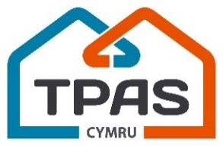
Annual General Meeting
11am Tuesday 17th November
Online Zoom Webinar

AGENDA

1. Opening welcome and address
Bill Hunt, (Chair, TPAS Cymru)

2. The 2019 – 2020 Annual Report
David Wilton (Chief Executive, TPAS Cymru)

3. The Finance Report
Jane Broad (Corporate Services Director, TPAS Cymru)

4. Governance Update
Bill Hunt (Chair, TPAS Cymru)

5. COVID-19 update on Events and Activities
David Lloyd (Programme Director, TPAS Cymru)

6. Questions and Answers
Vicki Miller, Vice Chair, TPAS Cymru)

7. Formal Close and Thanks

