
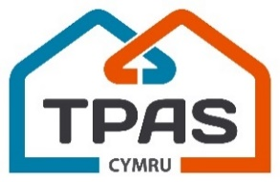
Annual General Meeting
5pm, Tuesday 10th November 2025
Metropole Hotel, Llandrindod Wells

AGENDA

 | 1. Opening welcome and address  Amanda Lawrence, (Chair, TPAS Cymru)
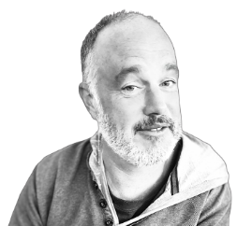   | 2. The 2025 – 2026 Annual Report  David Wilton (Chief Executive, TPAS Cymru)  3. Finance Report  Martin Little (Finance & Operations Manager, TPAS Cymru)
 | 4. Delivery Update and your views on next year’s priorities  David Lloyd (Programme Director, TPAS Cymru)
 | 5. Board Update  David Wilton (Chief Executive, TPAS Cymru)  Amanda Lawrence, (Chair, TPAS Cymru)
 | 6. Any Questions and Answers  Amanda Lawrence, (Chair, TPAS Cymru)
 | 7. Formal Close and Thanks

