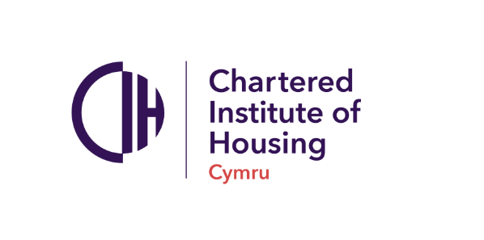

**For immediate release**

**CIH Cymru welcomes publication of the Homelessness and Social Housing Allocation (Bill)**

CIH Cymru welcomes today’s publication of the homelessness and social housing allocation bill. This bill proposes wide reaching changes to how homelessness is prevented and relieved in Wales. The bill provides a stronger emphasis on preventing homelessness in the first place. This includes wider public sector responsibility for identifying those individuals at risk of homelessness to ensure stronger cooperative working across Wales’ public services.

Yet whilst the new legislation is welcomed there are still significant structural issues that need to be addressed alongside the implementation of new homelessness legislation. Our 2025 Sector Snapshot asked respondent what was needed to end homelessness in Wales. Those responding were clear we need an increased supply of homes, increased funding and need to tackle wider housing unaffordability. Our previous snapshots in 2023 and 2024 have also outlined that the pace and scale of change has left staff feeling overwhelmed. High workloads are a major issue for local authority teams and a need for a larger workforce to effectively implement changes proposed by Welsh government.

The wide-ranging changes in the homelessness and social housing allocation bill are welcomed by the sector as people work in housing to make a difference in people’s lives. Something the new bill aims to do. However, we need to ensure that implementing the bill comes alongside additional support and significant investment into our workforce to support its implementation if we are to truly work towards ensuring homelessness in Wales is rare, brief and unrepeated.

Matt Dicks, national director of CIH Cymru said:

“The proposed bill outlines some significant changes to homelessness legislation in Wales. Its increased focus on preventing homelessness and a duty for the whole public sector to cooperate in preventing homelessness is welcome with its potential to reduce the number of households experiencing homelessness.”

“Whilst the legislation is a key part in the work to end our housing emergency, our workforce will need to be invested in and provided with the right level of resources to implement the legislation and ensure homelessness in Wales can truly be rare, brief and non-repeated”

“This investment must be across political cycles and the way we achieve this is to enshrine the right to a safe, affordable and sustainable place the call home into Welsh law. That is the mechanism through which we change the paradigm and truly end homelessness in Wales whilst ensuring housing professionals get the tools they need to do their job.”

**/ENDS**

For additional comments, interview arrangements or case studies please contact Catherine Bromley, Press and communications officer, 07843 626 042; catherine.bromley@cih.org

**Notes for editors**

**About the Chartered Institute of Housing (CIH)**

The Chartered Institute of Housing (CIH) is the professional body for people who work in housing, the independent voice for housing, and the home of professional standards. CIH has a diverse membership of people who work in both the public and private sector housing, in 20 countries on five continents across the world.

The organisation’s goal is to support housing professionals to create a future in which everyone has a place to call home by providing housing professionals and their organisations with the advice, support, and knowledge they need.

CIH is a registered charity and not-for-profit organisation with any profit made put back into the organisation to fund the activities carried out to support the housing sector.

Further information can be found at [www.cih.org](https://eur02.safelinks.protection.outlook.com/?url=http%3A%2F%2Fwww.cih.org%2F&data=05%7C02%7CCatherine.Bromley%40cih.org%7C97d89f44faee4f7d95eb08dd4a854655%7C0000e9ea9ee347939563177e444fb497%7C0%7C0%7C638748658445699053%7CUnknown%7CTWFpbGZsb3d8eyJFbXB0eU1hcGkiOnRydWUsIlYiOiIwLjAuMDAwMCIsIlAiOiJXaW4zMiIsIkFOIjoiTWFpbCIsIldUIjoyfQ%3D%3D%7C0%7C%7C%7C&sdata=F0pIz%2BpBPtFvUwepR2QYI%2BmDsekOVhID6fHKNsL74MM%3D&reserved=0)