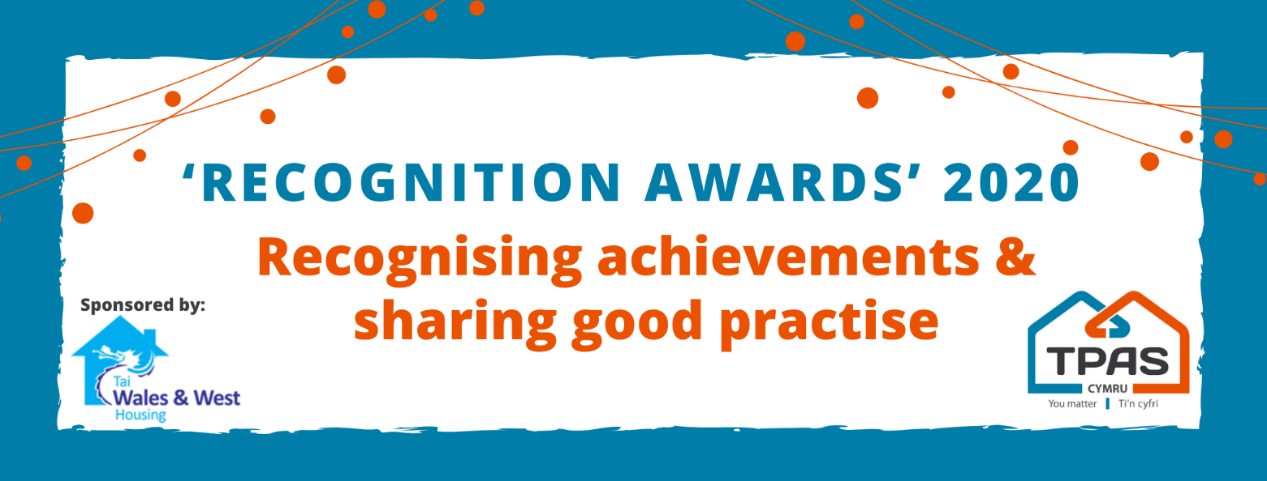

NOMINATION FORM

Title of Entry

Contact Name:

Address and postcode:

Tel number:

Email address:

An aim of the Awards is to share good practice with others. Will you be happy for us to share your contact details? Yes No

Which category is this nomination for?  Supporting Well being  Maintaining Tenant Participation during lockdown  Communication during a crisis  Communities supporting communities | Please ensure that your entry is submitted using this nomination form.  Focus on the facts, we don’t need lengthy text, bullet points are fine. Refer to the guidance criteria for each award and complete the standard nomination form under these specific headings  If you can, please include information such as photos/images/web links etc to demonstrate what you have done.  Ask us if you need assistance.
Type here under the criteria headings of your chosen award

No late entries will be considered

Please complete and return by noon 20th November 2020 to:
iona@tpas.cymru

NOTE: If you wish to send your nomination in Welsh ONLY, the earlier closing date of noon 16th November applies so that we have time to translate into English for our judges.

This event is kindly sponsored by:
