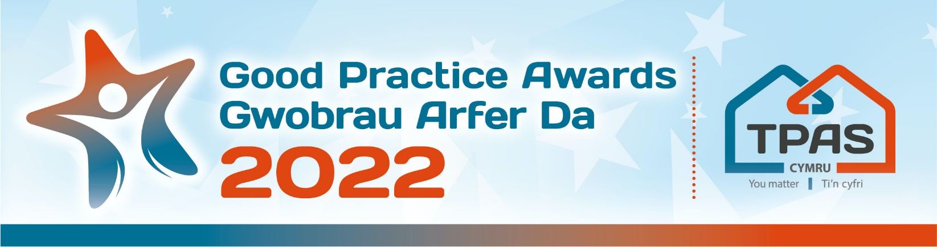

Assessment Criteria and Nomination Form for:

COMMUNICATING WITH TENANTS AND RESIDENTS

Assessment Criteria

This award recognises how effectively a social landlord communicates with its tenants and residents/service users. This could include a range of communication methods such as video, social media, newsletters, Facebook live and, direct ‘in person’ contact out in communities etc.

Tell us about how you communicate with your tenants and what difference it is making, such as; raising awareness of services or the support you offer, building relationships and understanding or being accountable about your organisation’s performance and plans. This award is inclusive of all methods of communication.

Judges will consider:

- The appropriateness of communication methods used in relation to diversity of the tenants e.g. plain language/avoiding jargon during communication.
- The effectiveness of the communication e.g. feedback from tenants/service users, social media analytics etc.
- Any lessons learnt and sustainability of the methods

- Please ensure that your entry is submitted by completing this nomination form and under the headings noted. The headings are the criteria which the judges will use.
- Focus on the facts – we don’t need lengthy text, detailed bullet points are fine
- Feel free to include supporting information e.g. share links to publications, flyers, websites etc
- Please include at least one photo/image/screenshot.
- Please also see Guidance Booklet for tips and conditions of entry

Interested in this category? Please complete the nomination form on the next page

Title of Entry:

Contact name:

Contact number:

Contact e-mail address:

An aim of the Awards is to share good practice with others. Will you be happy for us to share your contact details? Yes No

1. Summary of the aims/purpose of the project/work (MAX 100 words)
Type here

2a. The appropriateness of communication methods used in relation to diversity of the tenants e.g. plain language/avoiding jargon during communication (unlimited amount of words)
Type here

2b. The effectiveness of the communication e.g. feedback from tenants/service users, social media analytics etc (unlimited amount of words)
Type here

2c. Any lessons learnt and sustainability of the methods (unlimited amount of words)
Type here

3. Any further information you would like to share, please include it here (unlimited amount of words)
Type here

Please complete and return by noon 18th May 2022 to iona@tpas.cymru
No late entries will be considered

This event is kindly sponsored by:
