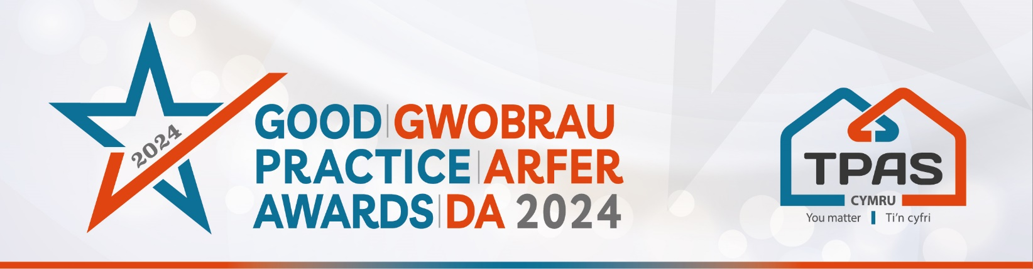

Assessment Criteria and Nomination Form for:

ENGAGING TENANTS IN ENVIRONMENTAL INITIATIVES/PROJECTS

Assessment Criteria

This new award recognises a landlord, organisation or community group which has successfully engaged Tenants/Residents in initiatives which benefit the environment, globally or locally!

We want to acknowledge those who are supporting tenants to engage in and benefit from environmentally focused initiatives. These could be: NetZero focussed projects, e.g. involving tenants in using low energy heating; reducing carbon footprints; tackling the climate emergency; biodiversity/nature projects or sustainable living.

So, tell us what you have been up to and what others could learn from it.

Judges will consider…

- Outline how you have engaged with tenants/residents and provided support to be as inclusive as possible.
- Outline the impact of the engagement to date and what the future impact may be.
- Include some testimonials/feedback comments from those you have engaged with.

- Please ensure that your entry is submitted by completing this nomination form and under the headings noted. The headings are the criteria which the judges will use.
- Focus on the facts – we don’t need lengthy text, detailed bullet points are fine
- Feel free to include supporting information e.g. share links to publications, flyers, websites etc
- Please include at least one photo/image/screenshot.
- Please also see Guidance Booklet for tips and conditions of entry

Interested in this category? Please complete the nomination form on the next page

Title of Entry:

Contact name:

Contact number:

Contact e-mail address:

An aim of the Awards is to share good practice with others. Will you be happy for us to share your contact details? Yes No

1a. Outline how you have engaged with tenants/residents and provided support to be as inclusive as possible
Type here

1b. Outline the impact of the engagement to date and what the future impact may be
Type here

1c. Include some testimonials/feedback comments from those you have engaged with.
Type here

2. Any further information you would like to share, please include it here
Type here

Please complete and return by noon 30th April 2024 to iona@tpas.cymru
No late entries will be considered

This event is kindly sponsored by:

