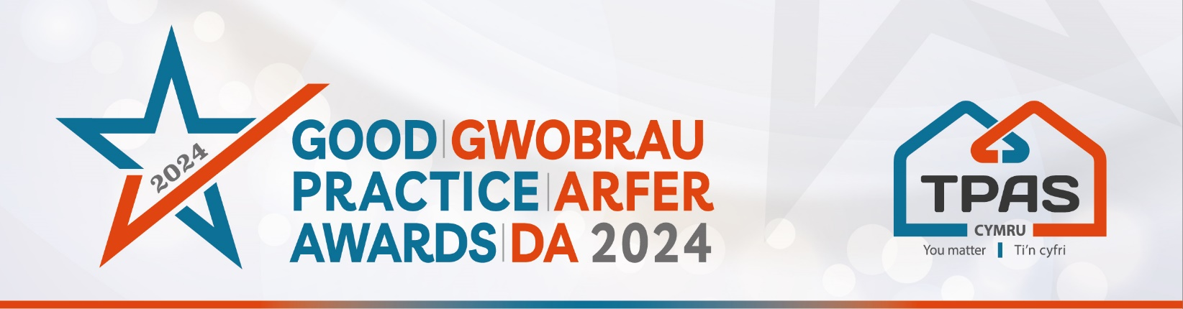

Assessment Criteria and Nomination Form for:

INVOLVING TENANTS IN SHAPING OR REVIEWING SERVICES

Assessment Criteria

This award will be made to a social landlord and/or a tenant led group who has successfully involved tenants/residents in shaping services or reviewing services e.g. designing new services, identifying service improvements, scrutinising or testing services. This could focus on one or more services which tenants receiive. Examples could include - repairs services, online services, complaints handling, reviewing service charge services.

Judges will consider:

- How tenants were included in shaping or reviewing the service i.e. the level of involvement/consultation, support offered to enable tenants to participate, and how inclusive the methods for getting involved were
- How services have been improved as a result of the tenant involvement
- What difference it has made/will make - the outcomes of the involvement

- Please ensure that your entry is submitted by completing this nomination form and under the headings noted. The headings are the criteria which the judges will use.
- Focus on the facts – we don’t need lengthy text, detailed bullet points are fine
- Feel free to include supporting information e.g. share links to publications, flyers, websites etc
- Please include at least one photo/image/screenshot.
- Please also see Guidance Booklet for tips and conditions of entry

Interested in this category? Please complete the nomination form on the next page

Title of Entry:

Contact name:

Contact number:

Contact e-mail address:

An aim of the Awards is to share good practice with others. Will you be happy for us to share your contact details? Yes No

1a. How tenants were included in shaping or reviewing the service i.e. the level of involvement/consultation, support offered to enable tenants to participate, and how inclusive the methods for getting involved were
Type here

1b. How services have been improved as a result of the tenant involvement
Type here

1c. What difference it has made/will make - the outcomes of the involvement
Type here

2. Any further information you would like to share, please include it here
Type here

Please complete and return by noon 30th April 2024 to iona@tpas.cymru
No late entries will be considered

This event is kindly sponsored by:

