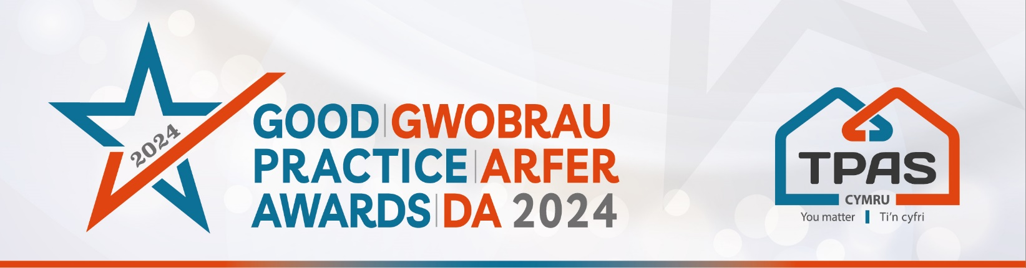

Assessment Criteria and Nomination Form for:

RESIDENT SUPPORT/ADVICE PROGRAMME

Assessment Criteria

This award will be made to a social landlord which is investing in and supporting tenants and communities. We are looking for well-established support/advice programmes that are helping residents to overcome challenges and enhance their lives and/or enhance opportunities.

Nominations should be able to demonstrate an effective approach to support/advice, anything from managing money and tackling debt to digital inclusion; warm hubs to education and employability. What we want to see evidence of the positive impact that the programme has had on the lives of residents.

Judges will consider:

- Evidence of the impact and positive outcomes for tenants, residents, or communities
- Whether the support can be sustained/adapted for the future
- How the support/advice has been inclusive of those it serves

- Please ensure that your entry is submitted by completing this nomination form and under the headings noted. The headings are the criteria which the judges will use.
- Focus on the facts – we don’t need lengthy text, detailed bullet points are fine
- Feel free to include supporting information e.g. share links to publications, flyers, websites etc
- Please include at least one photo/image/screenshot.
- Please also see Guidance Booklet for tips and conditions of entry

Interested in this category? Please complete the nomination form on the next page

Title of Entry:

Contact name:

Contact number:

Contact e-mail address:

An aim of the Awards is to share good practice with others. Will you be happy for us to share your contact details? Yes No

1a. Evidence of the impact and positive outcomes for tenants, residents, or communities
Type here

1b. The impact the support has had on individuals/communities
Type here

1c. Whether the support can be sustained/adapted for the future
Type here

2. Any further information you would like to share, please include it here
Type here

Please complete and return by noon 30th April 2024 to iona@tpas.cymru
No late entries will be considered

This event is kindly sponsored by:

