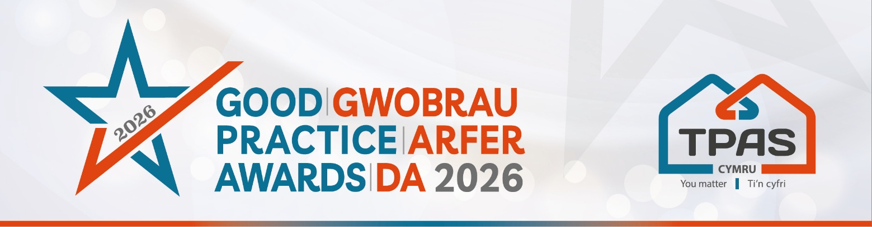

Assessment Criteria and Nomination Form for:

TENANT FOCUSED CONTRACTOR

Category Details
This award is open to DLO’s and contractors that are currently working with one or more of our member housing organisations at the time of nomination.

This award recognises contractors and DLO’s who consistently put tenants first in the way they plan and deliver their work. It focuses on how work is delivered and experienced by tenants, not just what is delivered.

It celebrates organisations that go beyond completing works, those who deliver through a positive, respectful and supportive experience for tenants.

Assessment Criteria:
- Putting tenants at the centre - How tenants need, experiences, and circumstances are considered throughout the delivery of the service, including effective communication and building trust with Tenants
- Listening and responding - How tenant feedback or concerns are actively listened to and used to shape how work is delivered.
- Positive tenant experience - Evidence from tenants showing how they were supported before, during, or after works. For example, this could include tenant feedback, practical examples or short case studies

Contractors are welcome to submit nominations in collaboration with a member housing organisation.

This award will be made to one outstanding entry.

- Please ensure your entry is submitted by completing this nomination form
- Make sure you reference the assessment criteria which the judges will use.
- Focus on the facts: we don’t need lengthy text, detailed bullet points are fine
- Feel free to include supporting information e.g. share links to publications, websites etc
- Please include at least one photo/image/screenshot.
- Please also see Guidance Booklet for tips and conditions of entry

Please complete the nomination form on the next page

Title of your Entry:
(this is what the nomination will be referred to in publications)
Contact Details of person submitting the nomination:

Name:

Telephone / Mobile number:

E-mail address:

An aim of the Awards is to share good practice with others. Will you be happy for us to share your contact details? Yes No

PROVIDE FULL DETAILS OF THE NOMINATION

Make sure you clearly cover all of the information in the assessment criteria for the category

Type here (there is an unlimited wordcount)

Please include at least one photo/image/screenshot – embed here or email separately

Please complete and return by noon 22nd April 2026 to iona@tpas.cymru
No late entries will be considered

This event is kindly sponsored by:


