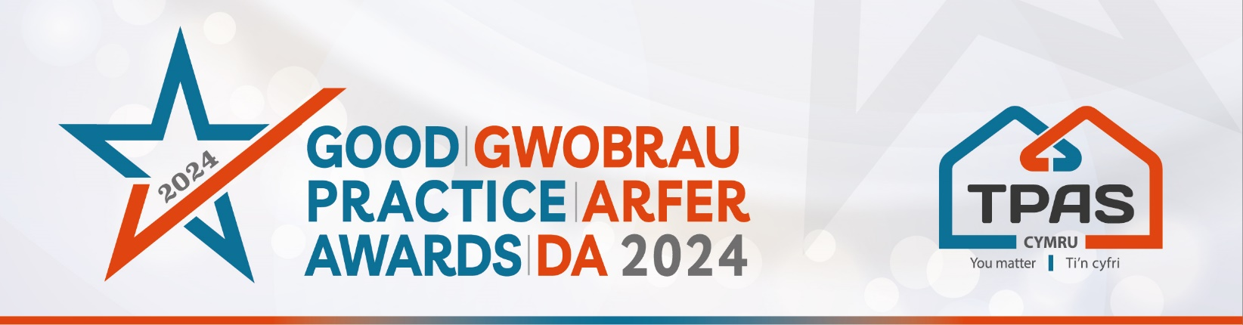

Assessment Criteria and Nomination Form for:

TENANT VOICE

Assessment Criteria

This award will be made to a social landlord who can demonstrate that their tenants/residents are actively supported to be engaged, involved, and empowered to influence services and decisions which affect them.

We want to know how the landlord is working to ensure the tenant voice is heard, listened to, and acted upon at all levels of the organisation. We also want to hear what you have in place to enable that to happen.

Judges will consider:

- How the organisation is working to ensure the tenant voice is heard, listened to, and acted upon at all levels of the organisation.
- How tenants are encouraged and supported to be involved. How do you raise awareness and get tenants engaged and involved?
- How the organisation is working to ensure the range of tenant’s voices are heard.

- Please ensure that your entry is submitted by completing this nomination form and under the headings noted. The headings are the criteria which the judges will use.
- Focus on the facts – we don’t need lengthy text, detailed bullet points are fine
- Feel free to include supporting information e.g. share links to publications, flyers, websites etc
- Please include at least one photo/image/screenshot.
- Please also see Guidance Booklet for tips and conditions of entry

Interested in this category? Please complete the nomination form on the next page

Title of Entry:

Contact name:

Contact number:

Contact e-mail address:

An aim of the Awards is to share good practice with others. Will you be happy for us to share your contact details? Yes No

1a. How the organisation is working to ensure the tenant voice is heard, listened to, and acted upon at all levels of the organisation
Type here

1b. How tenants are encouraged and supported to be involved. How do you raise awareness and get tenants engaged and involved?
Type here

1c. How the organisation is working to ensure the range of tenant’s voices are heard.
Type here

2. Any further information you would like to share, please include it here
Type here

Please complete and return by noon 30th April 2024 to iona@tpas.cymru
No late entries will be considered

This event is kindly sponsored by:

