Exterior, quality drinking water fountain
In 2014, the Friends of Belle Vue Park, Penarth wished to install a drinking water fountain as the park was popular with children, families, dog walkers and we wished to encourage people to refill their water bottle rather than buy single use disposable water.
The project had 2 considerations.
- We wanted function and quality. ie we wanted drinking access for children/wheelchair users plus make it easy to refill a water bottle. (drinking water fountains usually do only one 1 of those 2 requirements.
- Access to mains supply is key. We could not afford to dig up the park to connect to far away supply. The Vale Council had suitable survey plans and together we found a great spot that had nearby access to underground mains water supply.
We found that best designs/suppliers are from USA and we imported our chosen one (We were 1st in Europe for that design). Supplier was MIW (miw.co.uk). The model is a ‘Halsey Taylor 4420-BF1UDB - Endura II Tubular Outdoor Bottle Filling Station’. Purchase of drinking fountain - £2,873.
Note: it was a quality, 3 tier fountain (powder-coated and stainless steel)
- At the top, was a vertical supply that allowed you to refill a water bottle easily. (more for people 9yrs+ due to height)
- Mid-tier was a standard drinking access (with guard to stop you putting your mouth on the access point). The height allows wheelchair access and for children from about 4-5 years old.
- Bottom was a fresh water pet drinking bowl.
All surplus water from all 3 access points is drawn to a ‘soak away’ (for spec see later)
It then needs to be installed. Mounted on a firm ‘plinth’ base and have a ‘soak away’ under for surplus water.
A installer was chosen by Council for cost of approx. £1.5k. (details upon request)
(ie construction of the soak away, concreate plinth + the erection and connection of the Fountain)
Notes:
- The Council managed drawings/spec to potential suppliers inc water supply details.
- We had to have a special 'non-return valve' that didn't come as standard with the US import to ensure no contaminants get back into the mains water supply. The installer said sourcing, fitting the non-return valve was not a problem and was only a minor extra cost.
- The plinth for mounting the fountain on would have created a 2-inch lip which would have deterred wheelchair users, but fortunately due to slight ground slope, the key access side was nearly flush. Recommend you get the fixing plinth flush with ground.
- There is a 1m cube soak-away filled with large gravel underneath the plinth for the waste water (allowed by regulations as there is no grey water to dispose of).
- We were fortunate we had support of the Council who effectively managed the technical side. The Friends funded the cost (we got Section 106 money to assist) and we consulted residents/stakeholders etc on designs etc. For design -see below.
- The Council have since worked with another ‘Friends of’ park group to install a similar one.

Documented by The Friends of Belle Vue Park, Penarth
January 2017
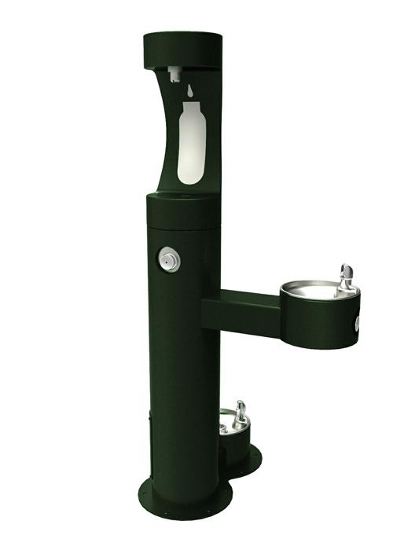
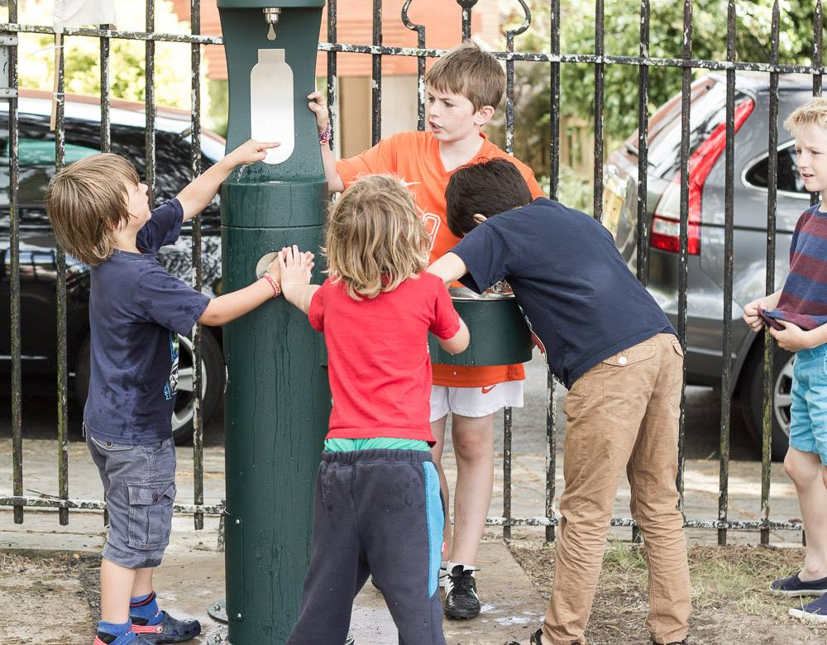
Personal observations of the author 4-5 years on (Jan 2019)
- Its been a great success. The kids love the mid-tier and parents used the top water bottle station. The dog bowl doesn’t get used that much, as our park has some dog restrictions.
- Occasionally the bottom and mid-tier needs a quick clean out as we have overhanging pine trees that drop needles. I’m aware of once in 4 years a quick ‘sink plunger’ was needed on bottom tier to release pine needle blockage.
- In heavy rainfall with significant ground water saturation, the soak-away can fill, leave some standing water in bottom bowl. However these conditions are low demand for the fountain.
- No sign of damage, wear or vandalism.

